Software Requirements Specification

**For MAJOR1**

# CPU Scheduling Algorithm analysis and Visualization

**17/OCT/2022**

# Mentored by

**Anupam Singh-AP SG**

# Prepared by

|  |  |  |
| --- | --- | --- |
| **Specialization** | **SAPID** | **Name** |
| BIGDATA | 500076739 | KESHAVGARG |
| BIGDATA | 500075361 | PRIYANKA DABRAAL |
| BIGDATA | 500077428 | ALAKH MEHTA |
|  |  |  |



## Department of InformaticsSchoolofComputerScience

UNIVERSITYOFPETROLEUM&ENERGYSTUDIES,

## DEHRADUN-248007.Uttarakhand

**Tableof Contents**

|  |  |  |
| --- | --- | --- |
| **Topic** | | **PageNo** |
| TableofContent | |  |
| 1 | Introduction | 3 |
|  | 1.1PurposeoftheProject | 3 |
|  | 1.2TargetBeneficiary | 3 |
|  | 1.3ProjectScope | 3 |
|  | 1.4References | 3 |
| 2 | ProjectDescription | 4-7 |
|  | 2.1ReferenceAlgorithm | 4 |
|  | 2.2ProposedAlgorithm | 5 |
|  | 2.3Data/Datastructure | 5 |
|  | 2.4SWOTAnalysis | 6 |
|  | 2.5ProjectFeatures | 6 |
|  | 2.6DesignandImplementationConstraints | 6 |
|  | 2.7Designdiagrams | 7 |
|  | 2.8AssumptionandDependencies | 7 |
| 3 | SystemRequirements | 7 |
|  | 3.1SoftwareInterface | 7 |
|  | 3.2HardwareRequirement | 7 |
| 4 | Non-functionalRequirements | 7 |
|  | 4.1Performancerequirements | 7 |
|  |  |  |
|  |  |  |
|  |  |  |
|  | |  |

# INTRODUCTION

### Purpose Of The Project

### The purpose of the project is to:

### Design a system that would automatically calculate turnaround time, average waiting time and throughput for different CPU scheduling algorithms.

### To visualize the working of different CPU scheduling algorithms through the visual representation of gantt chart of process working

### Target Beneficiary

The target beneficiary for the project are the undergraduate students who are exploring different kinds of CPU Scheduling Algorithm and looking at the. Thetarget beneficiary of our project can also be the people working in the field of computerscience looking for the easy explanation and visualization of these algorithms.

### Project Scope

### 

### This project can be integrated with an application or the web interface that can be used by the undergraduates to understand CPU scheduling algorithms.

### It can be used to visually different scheduling algorithms.

### References

### 

### [1] Suranauwarat, Sukanya. "A CPU scheduling algorithm simulator." *2007 37th annual frontiers in education conference-global engineering: knowledge without borders, opportunities without passports*. IEEE, 2007.

### [2] Goel, Neetu, and R. B. Garg. "A comparative study of cpu scheduling algorithms." *arXiv preprint arXiv:1307.4165* (2013).

### [3] Hasan, T.F., 2014. CPU scheduling visualization. *Diyala Journal of Engineering Sciences*, *7*(1), pp.16-29.

### <https://docs.python.org/3/library/tk.html>

### <https://matplotlib.org/stable/index.html>

# PROJECTDESCRIPTION

### ReferenceAlgorithm

### ● First Come First Served (FCFS): It is the most straightforward scheduling algorithm. It queues processes in the order that they arrive in the ready queue. The process which arrives first in the ready queue is served first. It is a non-preemptive scheduling algorithm, which means the processor cannot release the process before its execution is over. The FCFS scheduling is fair in the formal sense of fairness, but it is unfair in the sense that long jobs make short jobs wait and unimportant jobs make important jobs wait. It cannot cater to the execution of processes according to priority or importance.

### ● Shortest Job First (SJF): The algorithm gives priority to the shortest process available in the ready queue. It can be preemptive or nonpreemptive. The main problem with SJF is the necessity of previous knowledge about the time required for a process to complete. The process which has high Burst Time (BT) has to suffer most in this algorithm. This type of suffering is called 'ageing'.

### ● Round Robin (RR): This scheduling algorithm is based on the concept of time-sharing. It is the combination of first come first served (FCFS) scheduling algorithm and preemption among processes. To implement the RR scheduling algorithm, we keep the ready queue as a FIFO queue of processes.

### As a new process arrives, it will be inserted into the tail of the ready queue. A process is only given access to the CPU for a specified amount of time called Time Quantum' if it fails to execute completely in the time frame, it has to come again as a new process with the updated burst time.

### Proposed Algorithm

The user will create a user-defined queue with process id, burst timeand arrival time as attributes. The user is allowed to choose between several CPU scheduling algorithms such as First Come First Serve (FCFS), Shortest Job First (SJF),Round Robin and more.

If Round Robin is selected, the user is prompted to enter the desired time respectively.

After the user has inputted the desired algorithm, he/she will submit the algorithm for processing

and the output will be displayed. The displayed out will contain the process queue, the result of the

output parameters for the selected algorithm and also the results of the output parameters for the

default algorithm. This will not only provide an evaluation of the selected algorithms based on the

output parameters for the process queue

The gantt chart will be created for the respective algorithm and visually depicted.

### Data/Data Structure

### 

### Data: The processes details(process ID, burst time, arrival time) and the algorithm to be used.

### Data structure: Array

### SWOT Analysis

Strength :The developers of the project will get to know about how to implement various CPU scheduling algorithms including FCFS, SJF , Round Robin andhelp in  creating the visual representation through gantt chart.

Weakness: The users must have basic understanding of scheduling algorithms.

Opportunities: This interface can be integrate with application and used in real world.

Threats: The calculation made by the system is assumed to be correct.

### Project Features

### Create a user interface to automatically calculate the turnaround time, waiting time and throughput of CPU scheduling algorithm on the basis of user input of .different processes.

### User will be able to learn various CPU scheduling algorithms through our created interface.

### Visually understand the working of different CPU scheduling algorithms.

### Design And Implementation Constraints

The design of the project include the implementation and analysis of the algorithms like first come first serve(FCFS) ,shortest job first (SJF) and round robin . So the developers associated in the implementation must focus on the algorithm

### Design Diagrams

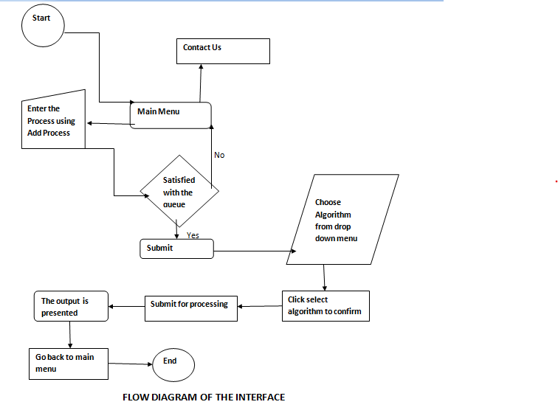

Fig 2.7.1: Flow diagram of the user interface.

### Assumptions and Dependencies

# SystemRequirements

### Software Interface

### Hardware Requirements

RAM=1GBis sufficientforstoring and managementofdata set.

|  |  |
| --- | --- |
| OperatingSystem | Requirement |
| Windows10, 8.1and 8 | Norequirements |
| Windows7, Vistaand XP | .NET4.5FrameworkRequired |

Table3.2.1

# Non-functional Requirements

### Performance Requirements

The project performs well when the data that is inserted in the format that is required and correct in the user’s knowledge.